# **Product Requirements Document**

|  |  |
| --- | --- |
| Target Release | August 16 2023 |
| Epic | MVP |
| Document Status | V1.0 |
| Document Owner | Vijay |
| Designer | Vishal |
| Tech lead | Shiva |
| Technical writers | Vishal & Pranav |
| QA | Aditya |

## **What**

We are Eatery, a new food delivery app on the market to help people fulfil their cravings — right from home-cooked, healthy food providing cutlery and utensils to the users.

**Why**

We Eatery, want to compete the market by providing quality, hygienic, healthy, maintaining temperature for food delivery along providing users cutlery and utensil to the user to have food at any accessible location they desired. We have following insights defined for our app after lot of analysis.

* Market survey indicated an average online food age is 15-64 years old users
* Most people use Swiggy & Zomato to order food online.
* Average meal cost was 200/- to 400/- and validated in interviews to have minimum food cost of 250/-
* Targeting more than metro cities – Tier 1, Tier 2 Cities including rural
* Most people want cutlery and utensils to have the food
* Tier 1 & Tier 2 people want to maintain the food temperature till food delivery
* 85% target audience are looking for homemade hygienic food.
* Need to provide refund and customer support

**Scope**

* In- Scope for the MVP

|  |  |
| --- | --- |
| **Feature** | **Reason behind choosing this as a ‘Must Have Feature’** |
| Login as a customer/Supplier/rider | One interface for all 3 entities to access, supply and deliver the food. User can login with touch id or face id. |
| Search by Voice & Manual search | Voice search helps user to search the food with ease. We also have manual search that helps user to search manually |
| Signup | Customer will register with his Gmail/ Facebook/twitter/ mobile number and can have touch id or face id defined |
| Profile Page | Customer/Supplier/Rider – Address information, Contact information, Email, Subscription information for customers, Supplier & Rider agreement |
| Filter & Sorting | User can filter food type by category and sort by cost, rating & relevance. User can avail home and hygienic food. |
| Menu/Order | User select the items as per their need and should view the incremental cart qty |
| Cart Items | User should view the selected menu items and should view the quantity correctly displayed and can increase each item quantity. |
| Maintain food temperature option | User have a feature to maintain the food temperature by availing this option |
| Table ware items – Cutlery & Utensils | User have a feature to add table ware items like – Plates, Cutlery, disposals…etc |
| Payment options | UPI integration, Single sign-on payment, Secured payment |

* Out of Scope for MVP (for future releases)

|  |  |
| --- | --- |
| **Feature** | **Reason behind choosing this as a ‘Nice to Have Feature’** |
| * Repeat Order * Delivery Instructions & Health Tips * Add Tips to Rider * Personalization & Themes * Rider Rating * Subscriptions, Offers & Rewards * Micro filtering to add ingredients * Most ordered information * Annual Order amount saved summary * Refer a friend * Ads & Promotions * Place order Pay later * Schedule delivery * Restaurant rating * Food preference * Guest User access * FAQ(S) * Touch id & Face Id Login * Supplier & Rider integration same app | Feature enhancements as it improves the market business. Users, Rider loyalty will increase. This will help and enhance more features once product goes live in the market. |

**How**

Create detailed Epics, Features and User Stories to chalk out requirements



|  |  |  |  |  |  |  |
| --- | --- | --- | --- | --- | --- | --- |
| **S.No** | **Epic / Feature** | **Feature** | **Work Item Title (User Story)** | **Priority** | **Jira Issue#** |  |
| 1 | Login Page | Mobile OTP login | As a user I need to tap the application in the device so that I can view the Login page screen | P1 |  |  |
| 2 | Login Page | Integrating Facebook. Twitter & Gmail | As a user I need to login with email successfully so that I can navigate to Home page | P1 |  |  |
| 3 | Signup Page | Supplier signup | As a supplier I need to navigate to Create account page and attach agreement so that I can create supplier account and become vendor to the eatery successfully | P2 | EYDE0369 |  |
| 4 | Signup Page | Rider signup | As a rider I need to navigate to Create account page and attach vehicle details and UIDAI details so that I can create rider account and be part of delivery services to the eatery successfully | P2 |  |  |
| 5 | Home Page | Most popular restaurants offerings | As a user I need to navigate to home page so that I can view the Menu and Search options along with restaurant offerings | P1 |  |  |
| 6 | Home Page | Voice search | As a user I do voice search for the food items (Voice Search) in home page so that I can view the exact voice Search results of different restaurant offerings | P1 | EYDE0420 |  |
| 7 | Menu Page | Screen background customization with respective seasonal | As a user I need to have menu option in home page so that I can navigate to menu page and can navigate to different pages to operate | P1 |  |  |
| 8 | Order Page |  | As a user I click on Restaurant option in Home page so that I can select food items to the cart | P2 |  |  |
| 9 | Cart Page |  | As a user I click on cart page option without adding any food items so that I can see empty cart page with options to Schedule | P2 |  |  |
| 10 | Payment page |  | As a user I can select different payment option so that I can pay my order successfully |  |  |  |
| 11 | Payment page |  | As a user I pay my order so that I can navigate to delivery tracking page successfully |  |  |  |
| 12 | Delivery tracking page |  | As a user I should view the delivery information clearly so that I can track my order |  |  |  |

**Wire Frames**

Low fidelity: <https://miro.com/app/board/uXjVP-zgpc8=/>

Prototype: <https://miro.com/app/board/uXjVP9O1tKY=/>

Workflow: https://miro.com/app/board/uXjVPjnA2tM=/

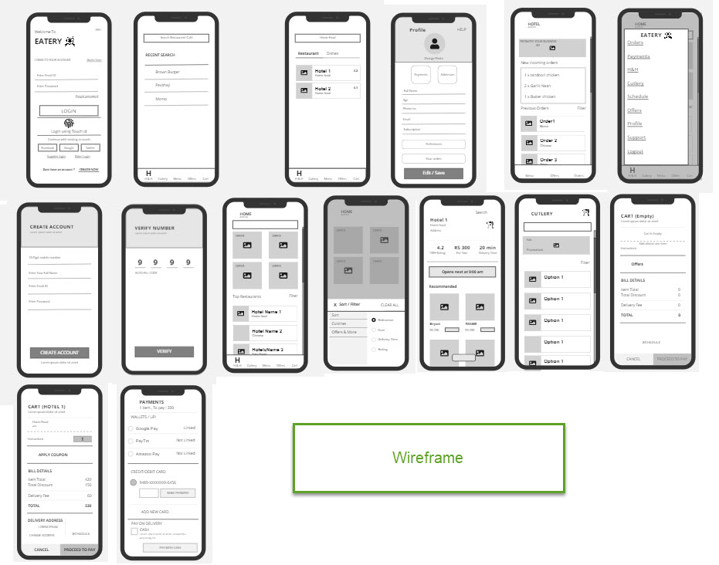

**Success metrics for the beta release**

|  |  |
| --- | --- |
| **Goal** | **Metric** |
| Adoption | * Adoption rate - new users / active users   4%   * Click-Through Rate - click-throughs from Paid ads & partnerships   2% |
| Activation | * App Downloads - number of downloads every week   220   * Orders Delivered - Orders placed/ Orders delivered   82%   * Subscription Rate - Number of active users/Number of subscriptions placed   15%   * Cutlery selection per week   12 orders per week |
| Retention | * Daily/Weekly/Monthly Active Users (DAU, WAU, MAU) -   6% average stickiness   * Revenue retention rate   78% |
| Engagement | * Repeat Purchase Rate - users who place frequent orders   24%   * Repeat Purchase Frequency - duration between repeat purchases -3.5 days * >12 mins of users’ engagement per day |
| Performance | * Session duration - average session duration for sessions where an order is placed   3:50 mins   * Customer Service requests for refund   2% of total orders placed per week   * Peek hour- Happy hour load   8 orders per hour |
| Security | * App crashes per week / Unsuccessful login events   .5% of total sessions |

## **Go-to-market**

* Target Maret –
  + 15–64-year-old individuals who live in Tier 1, Tier 2 cities location accessible
* Product Device Usage (App/web etc)
  + Mobile user includes Android & IOS users
  + Website users
* Pilot launch –
  + A/B Testing **July16th**
  + Pilot/BETA launch on **July 25th** for QA testing & UAT
  + MVP Launch on **Aug 16th**
* Pricing Model / Strategy
  + Our primary focus on Penetration pricing when we launch to capture a good share of the market. We have to remain competitive enough to thwart threats from offline tiffin service providers as well as bigger players like Zomato & Swiggy
  + Commission-based revenue share. 5% on pay-per-order, 10% on subscriptions, 10% on Marketplace purchases.
  + Happy hours plan – Providing happy hours food with more discount at peak hours from favourite restaurants.
  + Cutlery & Utensils – Provide cutlery and Utensils and increase 15% extra market share of orders
  + Pay-Per-Order Customers will pay - cost of their meal + delivery charges (if applicable)
  + Subscription with eatery will help user to procure the credits can then be used against orders & subscriptions

## **Release Timelines**

* MVP target launch – Jul 2023
* PRD for MVP complete – Jan 10 2023
* Wireframes – Jan 26, 2023
* UI design complete – Feb 5,2023
* Development complete for the MVP – May 15,2023
* SIT / Internal QA – May 15-June 10,2023
* Production Release – August 14th ,2023

,,,,,,,,,,,,,,,,,,,,,,,,,,,,,,,,,,,,,,,,,,,,,,,,,,,,,,,,,,,,,,,,,,,,,,,,,,,,,,,,,,,,,,,,,,,,,,,,,,,,,,,,,,,,,,,,,,,,,,,,,,,,,,,

Disclaimer:

All content and material on the upGrad website is copyrighted material, either belonging to upGrad or its bonafide contributors and is purely for the dissemination of education. You are permitted to access print and download extracts from this site purely for your own education only and on the following basis:

* You can download this document from the website for self-use only.
* Any copies of this document, in part or full, saved to a disc or to any other storage medium may only be used for subsequent, self-viewing purposes or to print an individual extract or copy for non-commercial personal use only.
* Any further dissemination, distribution, reproduction, copying of the content of the document herein or the uploading thereof on other websites or use of the content for any other commercial/unauthorised purposes in any way which could infringe the intellectual property rights of upGrad or its contributors, is strictly prohibited.
* No graphics, images or photographs from any accompanying text in this document will be used separately for unauthorised purposes.
* No material in this document will be modified, adapted or altered in any way.
* No part of this document or upGrad content may be reproduced or stored in any other web site or included in any public or private electronic retrieval system or service without upGrad’s prior written permission.
* Any rights not expressly granted in these terms are reserved.